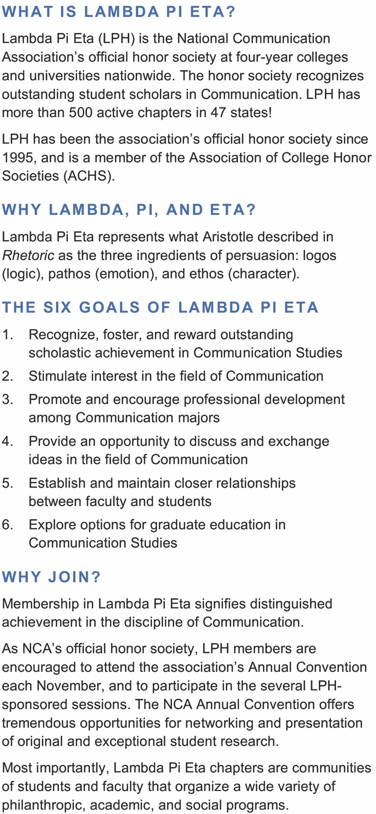
eligibility
To be eligible for admission, students must meet the following criteria:
- Complete 60 semester credit-hours or more
- Have a minimum cumulative GPA of 3.0 for all courses taken
- Complete 12 semester credit-hours or more in communication (COMM)
- Have a minimum GPA of 3.25 for all communication courses (COMM)
To join our MTSU chapter:
Every student member must submit the national initiation fee ($35) and completed form to the chapter faculty advisor prior to induction (deanne.priddis@mtsu.edu). This one-time fee covers your Lambda Pi Eta lifetime membership (http://www.natcom.org/LambdaPiEta).
Please make the check payable to MTSU and put it in Dr. Priddis’s mailbox in Jones Hall 233.
Email your questions and/or completed form to deanne.priddis@mtsu.edu.
2. Once the faculty advisor submits the fee to Awards Concepts, the student will be sent a personalized induction certificate and a Lambda Pi Eta lapel pin. If you wish to also order gold Honor cords, add the additional $18 to your check ($35+$18=$53) to MTSU and watch for an email to arrange to pick up from the Communication Studies office (Jones Hall 233).
Again, if you meet the criteria, CONGRATULATIONS on your academic achievement! Dr. Priddis, Faculty Advisor

Subhead
- List with bullets
Alpha Gamma Lambda Chapter Acceptance Form

Lambda Pi Eta (LPH) is the National Communication Association’s official honor society at four-year colleges and universities, and seeks to recognize the academic achievement of outstanding students in Communication.
To be eligible for admission, undergraduate students must meet the following criteria:

- Completed 60 semester credit-hours
- Have a minimum overall cumulative GPA of 3.0
- Completed 12 semester credit-hours in Communication Studies
- Have a minimum GPA of 3.25 for all Communication Studies courses
- Currently be enrolled as a student in good standing, as determined by the institution's policies
- Rank within the highest 35 percent of one’s class in general scholarship

I, ______________________________, having been invited to join the Alpha Gamma Lambda chapter of Lambda Pi Eta at MTSU, do officially submit my acceptance form. I have also enclosed a check for $35 to pay my one-time membership dues for induction into Lambda Pi Eta. Add $18 fee for honor’s cords (optional).

_________________________________________ ______________
Student Signature Date

_____________________________________________________________
Above please clearly print your name as you would like it to appear on your membership certificate

MTSU Email Other Email

Cell Phone Anticipated Graduation

M# Are you interested in a leadership role?

Please return this acceptance form and a check payable to MTSU to Dr. Priddis, or the Communication office at Jones Hall 233.
Completed form and questions can be directed to the Chapter Advisor at deanne.priddis@mtsu.edu.



